Project Design Phase-II
Technology Stack (Architecture & Stack)

Date | 31 January 3035
Team ID
Project Name
Maximum Marks | 4 Marks

Technical Architecture:
The Deliverable shall include the architectural diagram of the Blog Nest application as below and the information as per Table 1 & Table 2.
Example: Blog Nest – Web-Based Blogging Platform
The technical architecture of Blog Nest shows how users interact with the web application, how blog-related requests are processed, and how user and blog data are stored and managed in the database.

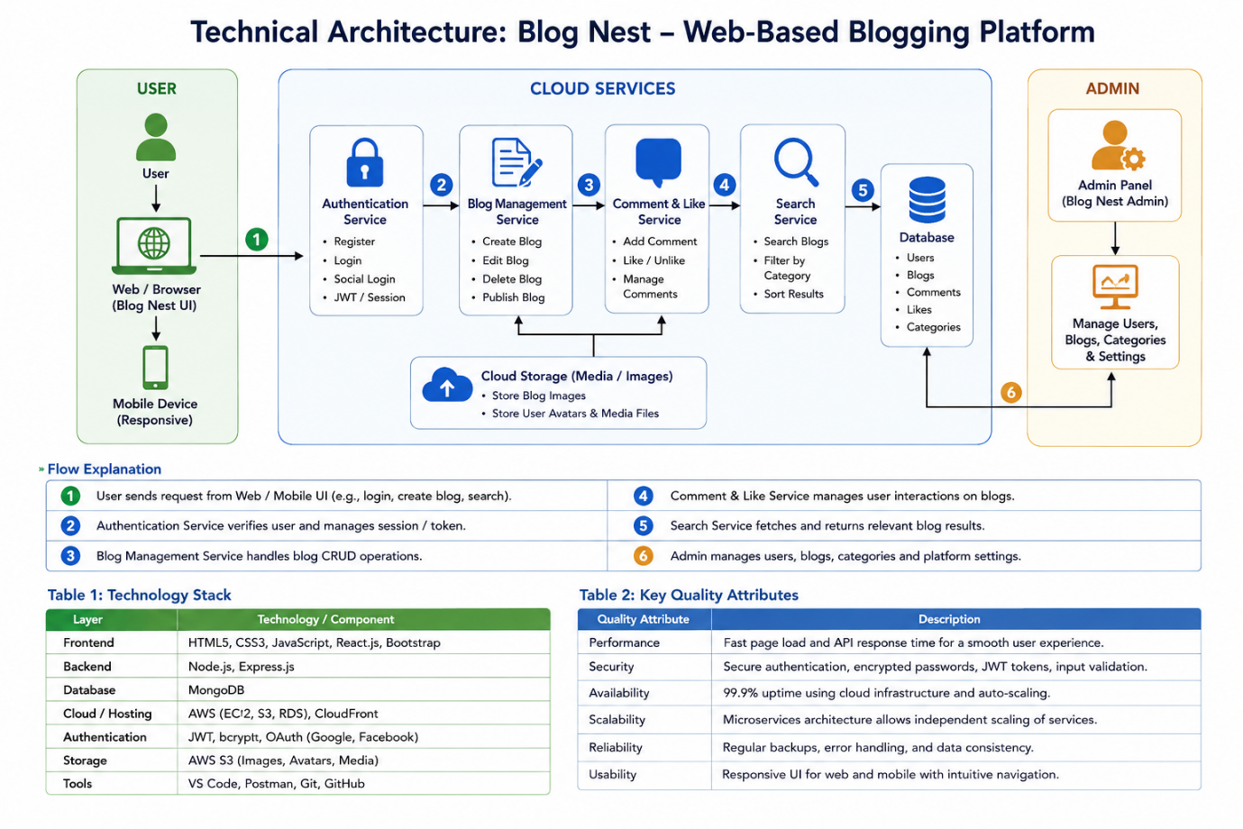

Guidelines:
• Include all the processes involved in Blog Nest as application logic / technology blocks.
• Provide infrastructural demarcation between Local and Cloud components.
• Indicate external interfaces such as third-party APIs, if applicable.
• Indicate data storage components / database services used by Blog Nest.
• Indicate storage for user details, blog posts, comments, likes, and other required data.
• Indicate the interface between Blog Nest and external services or APIs, if applicable.
• Indicate any machine learning model interface, if applicable.

Table-1: Components & Technologies
S.No | Component | Description | Technology
1 | User Interface | How users interact with the Blog Nest application through web pages. | HTML, CSS, JavaScript, React.js
2 | Application Logic-1 | Handles user registration, login, authentication, and profile management. | JavaScript / Node.js
3 | Application Logic-2 | Handles creating, editing, deleting, publishing, and viewing blog posts. | Node.js / Express.js
4 | Application Logic-3 | Handles comments, likes, search, and blog category operations. | Node.js / Express.js
5 | Database | Stores user details, blog posts, comments, likes, and categories. | MongoDB
6 | Cloud Database | Database service used to store Blog Nest data on the cloud. | MongoDB Atlas
7 | File Storage | Stores images and other files uploaded for blog posts. | Local File System / Cloud Storage
8 | External API-1 | Used for external services required by the application, if applicable. | REST API
9 | External API-2 | Used for additional external services or integrations, if applicable. | REST API
10 | Machine Learning Model | Machine learning is not required for the basic Blog Nest application. | Not Applicable
11 | Infrastructure (Server / Cloud) | Used to deploy and run the Blog Nest application. | Local Server / Cloud Server

Table-2: Application Characteristics
S.No | Characteristics | Description | Technology
1 | Open-Source Frameworks | Open-source frameworks are used to develop the user interface and backend of Blog Nest. | React.js, Node.js, Express.js
2 | Security Implementations | User authentication and password protection are implemented to secure user accounts and blog data. | Authentication, Password Hashing, HTTPS
3 | Scalable Architecture | The application can be expanded by adding more users, blogs, categories, comments, and features. The frontend, backend, and database can be managed separately. | React.js, Node.js, MongoDB
4 | Availability | Blog Nest can be deployed on a server or cloud platform so users can access the application through the internet. | Cloud Server / Web Server
5 | Performance | The application is designed to provide fast page loading, efficient blog searching, and quick database operations. | React.js, Node.js, MongoDB

